eDIANA: a new architectural approach for ICT-enabled energy efficient buildings

Janne Peltonen
Building Services and Indoor Environment
VTT Technical Research Centre of Finland
Espoo, Finland
janne.peltonen@vtt.fi

José Javier de las Heras
Research and Development Department
ACCIONA Infraestructures S.A.
Madrid, Spain
josejavier.heras.bueno@acciona.es

Rafael Socorro
Research and Development Department
ACCIONA Infraestructures S.A.
Madrid, Spain rafaelclaret.socorro.hernandez@acciona.es

Abstract— eDIANA will provide a Reference Architecture for a network of composable, interoperable and layered embedded systems that will be instantiated to several physical architectures.
Keywords (ICT, energy efficiency, smart building, reference architecture)

Introduction
According to the European Union Directive on the Energy Performance of Buildings (EPBD 2002/91/EC), buildings are responsible of more than 40% of the energy consumption in Europe.
Moreover, buildings are the largest source of CO2 emissions (about 1/3) in the EU27. The tendency shows that the total energy consumption has been rising since 1990 and will continue if strong actions are not taken. The challenge is to reduce the energy consumption (compared to 2005) and GHG emissions (compared to 1990) by 20% by 2020. In this reduction, buildings shall contribute accordingly.
ICTs and, therefore, embedded systems, as an enabling technology for energy efficiency shall, as stated by the European Commission in its communication addressing the challenge of energy efficiency through ICT, strongly contribute to the challenge. While such systems exist today, their effectiveness is often limited by a lack of interoperability, leading to fragmentation and limited overall impact. The project that is presented in this text is a strongly application-oriented initiative which is focused on the conceptualization, design, development, demonstration and validation of new devices operating in a uniform platform called eDIANA.

The eDIANA Platform is a reference model-based architecture, implemented through an open middleware including specifications, design methods, tools, standards, and procedures for platform validation and verification. eDIANA Platform will enable the interoperability of heterogeneous devices at the Cell and MacroCell levels, corresponding respectively to a living/working unit (one house, one office, etc.) and to a residential or non-residential building (usually composed of several Cells) and it will provide the hook to connect the building as a node in the producer/consumer electrical grid.
The eDIANA Consortium would like to acknowledge the financial support of the European Commission and National Public Authorities from Spain, Netherlands, Germany, Finland and Italy under the ARTEMIS Joint Technology Initiative.
Thus, eDIANA will provide a Reference Architecture for a network of composable, interoperable and layered embedded systems that will be instantiated to several physical architectures. The eDIANA Platform realisations will then cope with a variable set of location and building specific constraints, related with parameters such as climate, Cell/MacroCell configuration (one to many, one to one etc), energy regulations etc.

eDIANA ARCHITECTURE

The eDIANA Reference Architecture covers all the present and future elements involved in the energy management of the house-buildings, taking into consideration the different grades or levels of comfort that those elements provide to the user.
The eDIANA Reference Architecture is a hierarchical and open architecture; it does not demand a unique implementation of its elements so it enables the addition of new components, change and update them whilst they are compliant with the architecture.
This is why the eDIANA Reference Architecture is based on components located in different levels. All the components interact with the rest of the Platform components through interfaces. These interfaces allow the communication between components in the same level or different level.
The eDIANA components are logical, their implementation can be translated to a device for each component; however this is not compulsory, several components can be implemented in the same device. The component classification and characterization plus their interfaces enable to model the architecture so that an implementation of the eDIANA architecture will admit any device that hosts an eDIANA component with its correspondent interface.

Figure 1 shows how the eDIANA Platform (EDP) interacts with the outside. The local environment interacts with the lower level of the platform, this environment refers to the elements of the building that eDIANA Platform controls to achieve the objectives of energy efficiency and user comfort.
Figure 1, eDIANA Platform and external and local environment
On the other hand, the external environment interacts with the upper level of the platform, this environment refers to the building outside, in eDIANA Context the Power Grid, and the Platform remote access.
As previous sections have described, eDIANA Reference Architecture has a hierarchical organization, there are two levels that make up the eDIANA Platform (EDP), the MacroCell level and Cell level.
eDIANA Reference Architecture defines several components for each layer, attending the functionality each layer should provide. Considering a bottom-up approach and description, Cell Level integrates all components that interact with the building elements and devices: appliances, lighting, HVAC, etc. eDIANA Reference Architecture defines the next component types inside eDIANA Cell Level (see 1):
- Cell Device Concentrator (CDC)
- Cell User Interface (CUI)
- Cell Monitoring and Metering (CMM)
- Cell Control and Actuation (CCA)
- Cell Generation and Storage (CGS)
An implementation of eDIANA Reference Architecture can separate these components into different devices or integrate some of them into one.
More specifically, the last three component types undertake the task of obtaining all the information about the energy consumption of all elements of the building, communicating with the Cell Device Concentrator through the iEi (intelligent Embedded interface) and executing the orders that above components and layers define.
The communication between these components is hierarchical too; CMM, CCA and CGS can only communicate with the CDC. The architecture defines a unique interface, the iEi, to accomplish this task. In the definition of this interface, the architecture will describe the functionality required by all the components that use it, although a component may not implement all the services that the complete interface provides, only the ones that concern with the component.
The Cell User Interface is another component in the Cell level. It communicates only with the CDC in order to provide Cell level information to the user of the platform.
Keeping on the bottom-up approach, the CDC is in charge of the communications between the Cell level and MacroCell level. This communication is made between the CDC and the MCC, through the interface c2MCCi (Cell to MacroCell Concentrator interface).
The components that the eDIANA Reference Architecture defines at MacroCell level are:
- MacroCell Concentrator (MCC)
- MacroCell Control Strategies (MCS)
- MacroCell Data Gathering (MDG)
- MCC User Interface (MUI)
The components placed in this MacroCell level interact with the external environment in order to obtain information to elaborate the necessary strategies. These strategies will take into account the external environment (data from Power Grid-PwGRIDi and external resources-WWWi) and the information of the cells that are in charge of that MacroCell when producing the recommendations to Cell Device Concentrator.

eDIANA SCENARIO EXAMPLE
As it was explained before, the platform is flexible enough to be used in several kinds of buildings. A good example of this could be an apartment building, which the concrete Cell/MacroCell configuration is explained in figure 2.

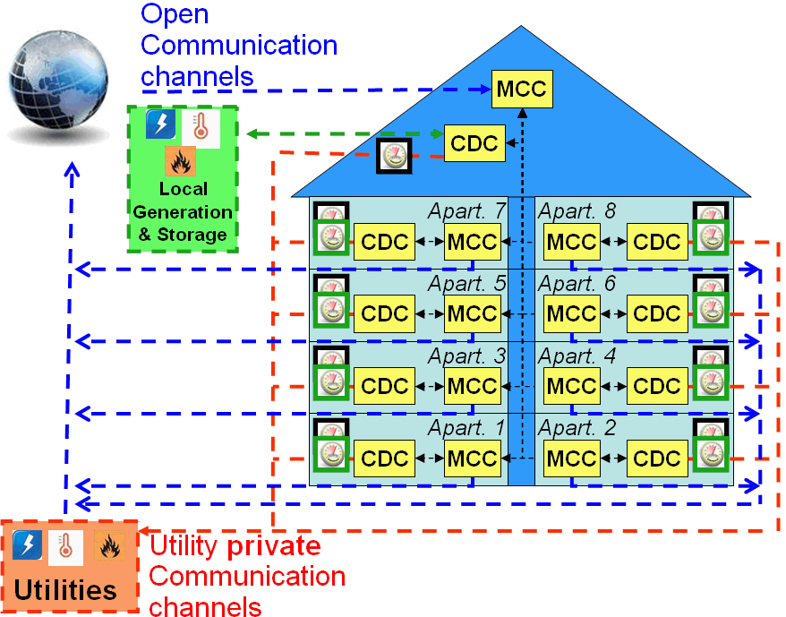

Figure 2 Apartment building with communal energy generation and storage capabilities
In an apartment building with communal local energy generation and storage capabilities the next Cell/MacroCell configuration is applied (see Figure 2):
- One MacroCell that corresponds to the building (with its MacroCell Level concentrator, Data Gathering Component, implemented Control Strategies and User Interface devices). The building MacroCell contains:
  - A cell with the communal capabilities of the building that contains:
    - A Cell level Concentrator (CDC)
    - Solar panels (Generation & Storage)
    - UI channels (User Interface)
- A MacroCell for each apartment with its MacroCell Level concentrator, Data Gathering Component, implemented Control Strategies and User Interface devices) that contains:
  - A cell that corresponds to each apartment:
    - A Cell level Concentrator (CDC)
    - Activity and presence sensors (Monitoring and Metering)
    - Devices that can be controlled by the System (Control and Actuation devices):
      - Household appliances such as dishwasher, washing machine, fridge, etc
      - Lamps and lights
    - UI channels (User Interface)
All the MCCs could interact among them in order to reach common goals, especially the MCC of the building MacroCell and the MCCs of apartments.

Finally, using the shown configuration, a simple use case is described using bullet points:
- In the morning before going to work, Frank (of the apartment 5) wakes up and puts the dishwasher and washing machine in the energy saving mode.
- The MCC of the building gets data from Forecast services: a sunny weather is expected (so sufficient energy will be generated by the solar panel).
- The MCC of each apartment gets data from Cell level concentrators (aggregated instantaneous energy consumption, aggregated estimated energy consumption, comfort related data, etc.).
- The MCC of each apartment will interact with the MCC of the building and will let it know the forecast consumption and production values for each apartment. The MCC of the building will let know the forecast energy production by communal solar panels.
- Each MCC will interact with the local electrical distribution company and will let it know the forecast consumption and production aggregated values and will get from the company information about electricity prices and costs.
- The MCC of apartment 5 knowing the real-time electricity price and forecast energy production by solar panels and applying the energy policies will let know Cells that it is a good moment to schedule to start the devices that are in the energy saving mode.
- The CDC of Apartament 5 will switch on dishwasher and washing machine.
- In the evening, when Frank (of the apartment 5) comes home. He checks the energy consumption of the day using a wall display (UI channel).
- In the evening, energy consumption is higher in most of the apartments. For instance, Tim (of the apartment 8) is at home cooking and watching TV and Frank (of the apartment 5) is working in his laptop and his children are watching a DVD.
- The MCC of each apartment that knows the real-time price of electricity (high at this moment) and has interacted with the rest of MCCs, will let know Cells that it is a good moment to reduce energy consumption.
- In each apartment, following the policies of its MCC, lights in unoccupied rooms are turned off automatically. Cell Level concentrator will get data from activity and presence sensors and will send orders to switch off lights to actuators.

Acknowledgment
Thanks to the eDIANA Consortium, that consists of 21 partners from Spain, Italy, Netherlands, Germany and Finland. eDIANA partners according to the alphabetic order are: ACCIONA Infraestructuras, ATOS Origin, Elsag Datamat, European Software Institute, FAGOR Electrodomésticos, Fidelix, GAIA, IKERLAN, Information & Image Management Systems, Infineon Technologies, LABEIN, Mondragon Goi Eskola Politeknikoa, Philips Electronics Netherlands, Philips Consumer Lifestyle, Philips Research, QUINTOR, ST Microelectronics, University of Bologna, University of Rome La Sapienza, VTT and ZIV Medida.

References

- eDIANA Public website: http://www.artemis-ediana.eu/
- Energy Performance in Buildings Directive (EPBD) Directive 2002/91/EC of the European Parliament and of the Council
- SMART 2020: Enabling the low carbon economy in the information age. The Climate Group http://www.theclimategroup.org/news_and_events/smart2020pressrelease
- Energy Labelling of Domestic Appliances - http://ec.europa.eu/energy/demand/legislation/domestic_en.htm
- “The Effectiveness Of Feedback On Energy Consumption. A Review For Defra Of The Literature On Metering, Billing And Direct Displays”. Sarah Darby. April 2006. Environmental Change Institute. University of Oxford
- Impacts of Information and Communication Technologies on Energy Efficiency. Draft Report. European Commission DG INFSO. May 2008
- Christian Möllering, Jürgen Löwenhag. Communications containers for smart appliances, 2007
- "The Hipeac Roadmap on Embedded Systems" - "Future of Embedded Systems Technology". BCC Report G-229R.

